Project Development Phase
Dashboard & Story Screenshots

Field | Details
Team Lead | Govindu Kavya Sri
Team Members | Eswari Gayatri Budumuru, Kiladi Kalavathi, Adaka Mounika, Panditi Jyostna
Domain | Retail / Cosmetics Analytics
Tools Used | Python, Microsoft Excel, Tableau Public
Dataset | Cosmetics product dataset — 1,472 records, 11 attributes
Published Dashboard | public.tableau.com/app/profile/govindu.kavya.sri/viz/cosmeticproject_17872016666220/Dashboard1

Project Context
The cosmetics industry is one of the fastest-growing and highly competitive sectors, driven by changing consumer preferences, diverse skin types, brand innovation, and evolving pricing strategies. With increasing demand for personalized beauty products, companies rely on data-driven insights to understand market trends, consumer behavior, and product performance.
This project, “Cosmetic Insights: Navigating Cosmetics Trends and Consumer Behavior with Tableau,” focuses on analyzing a cosmetics dataset to uncover meaningful patterns and actionable insights. The dataset includes key attributes such as brand, product category, price, rank, and skin type suitability (Dry, Oily, Combination, Normal, and Sensitive).
This project is designed to help businesses and analysts understand cosmetics market trends and consumer preferences. By analyzing brand performance, pricing patterns, product distribution, and skin-type coverage, the dashboard enables stakeholders to identify high-performing products, target specific customer segments, and optimize marketing and product strategies.

Scenario 1: Monitoring Consumer Preferences
In a real-time scenario, imagine receiving an alert indicating a concerning trend in consumer preferences, such as a significant decline in interest in certain cosmetic products or ingredients. Using the Cosmetic Insights data, we can promptly assess the extent and potential impact of this trend, identify contributing factors, and deploy immediate interventions to adapt product offerings and marketing strategies. Whether it's through targeted promotional campaigns, adjustments in product formulations, or personalized recommendations, real-time analysis enables agile decision-making and proactive measures to meet evolving consumer needs.

Scenario 2: Addressing Product Concerns
In the event of identifying widespread product concerns, such as negative reviews or safety issues associated with specific cosmetic items, real-time access to Cosmetic Insights data enables swift response and management. Cosmetic companies and regulatory bodies can utilize the dataset to gather crucial information about the concerns, including their prevalence, potential impacts on consumer trust, and affected product demographics. By leveraging real-time analytics, they can implement quality control measures, recall products if necessary, and communicate transparently with consumers to address their concerns and maintain brand integrity.

Scenario 3: Predictive Analysis and Product Innovation
Leveraging predictive analytics capabilities, Cosmetic Insights empowers companies to anticipate and respond to emerging trends and consumer preferences in the beauty industry. By analyzing historical data and identifying predictive indicators, companies can proactively innovate new products, adjust existing formulations, and tailor marketing strategies to meet evolving consumer demands. Real-time monitoring of market trends, consumer feedback, and competitor activities enables timely interventions, product innovation, and strategic decision-making to stay ahead in a competitive market landscape.

1. Dashboard
Live on Tableau Public: public.tableau.com/app/profile/govindu.kavya.sri/viz/cosmeticproject_17872016666220/Dashboard1

Individual Worksheets
The four worksheets below were built individually before being combined into Dashboard 1.
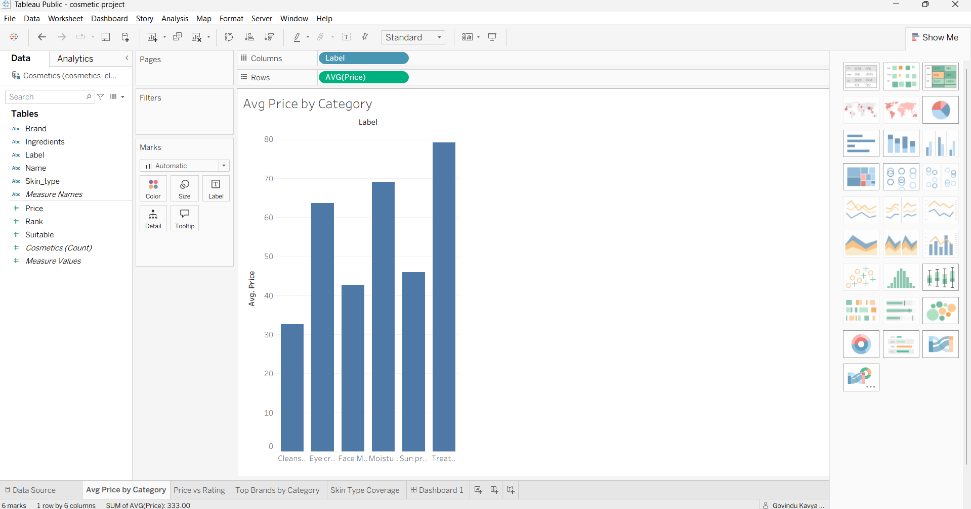
Worksheet 1 — Avg Price by Category
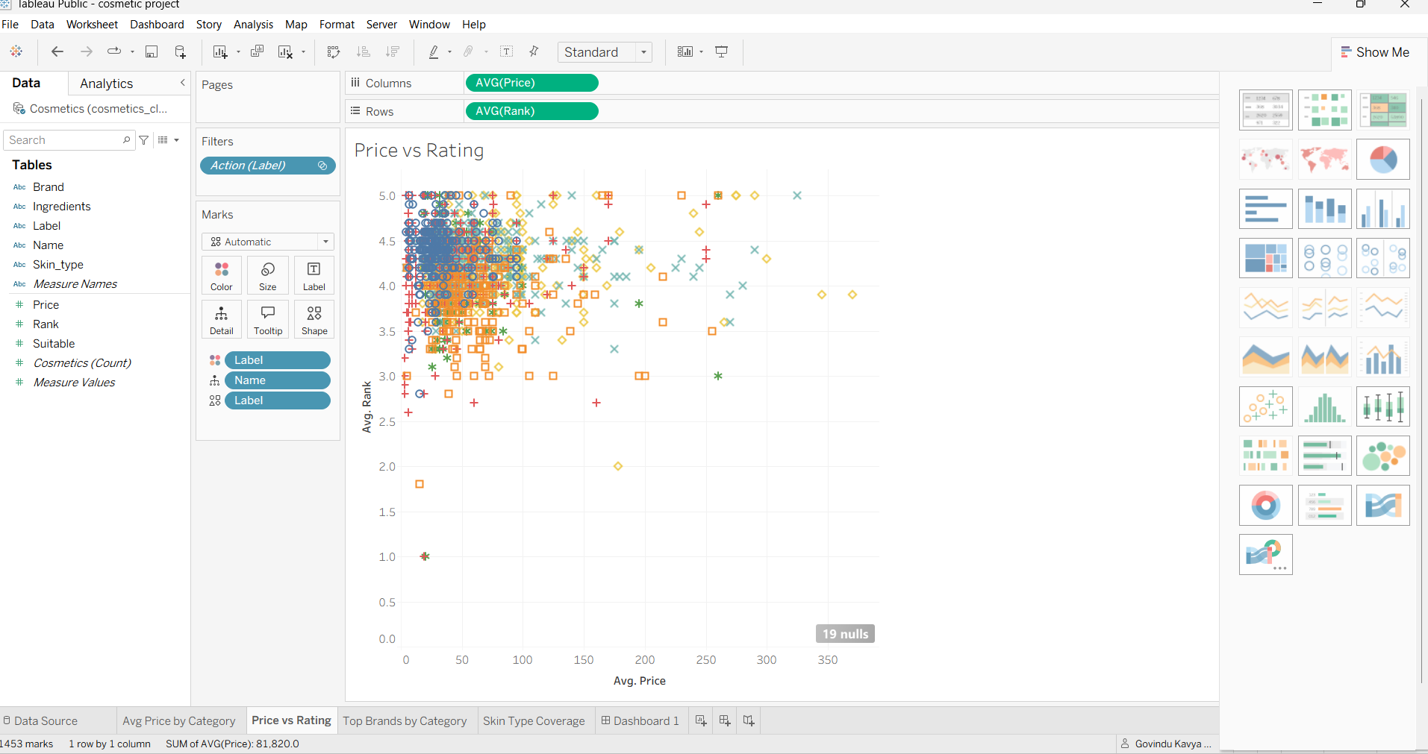
Worksheet 2 — Price vs Rating
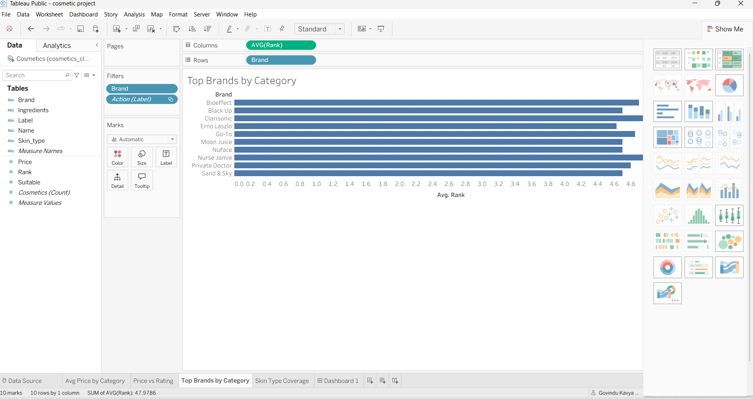
Worksheet 3 — Top Brands by Category
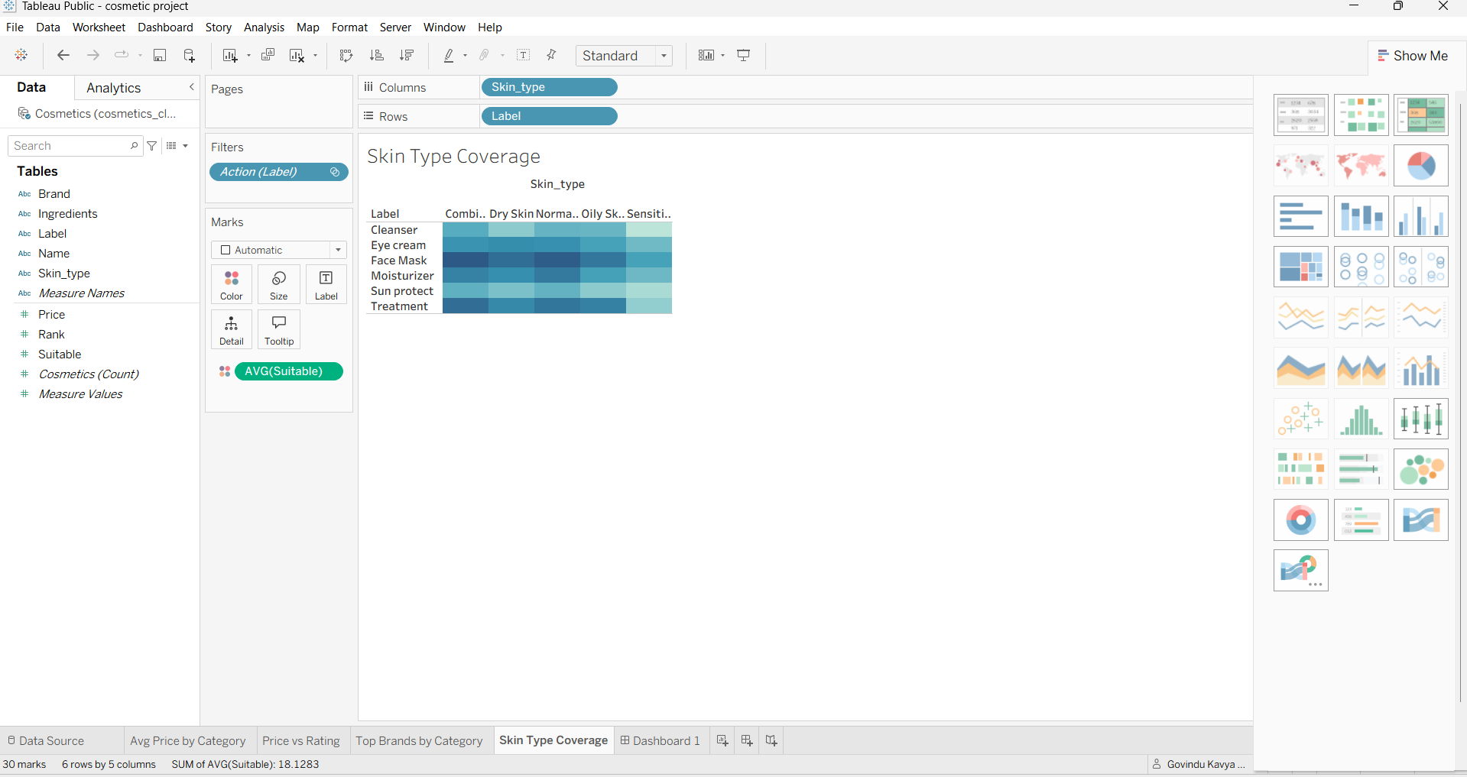
Worksheet 4 — Skin Type Coverage

Dashboard 1 — Cosmetic Insights: Trends & Consumer Behavior
Combines all four worksheets — Avg Price by Category, Price vs Rating, Top Brands by Category, and Skin Type Coverage — into a single interactive dashboard, with cross-chart filter actions and a searchable Brand filter on the right-hand side.
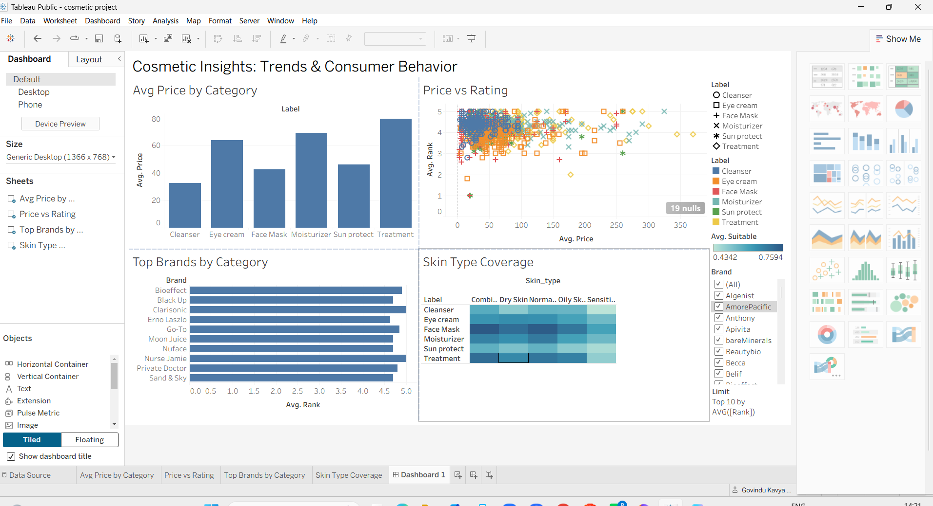
Dashboard 1 — Cosmetic Insights: Trends & Consumer Behavior (Tableau Desktop editing view)
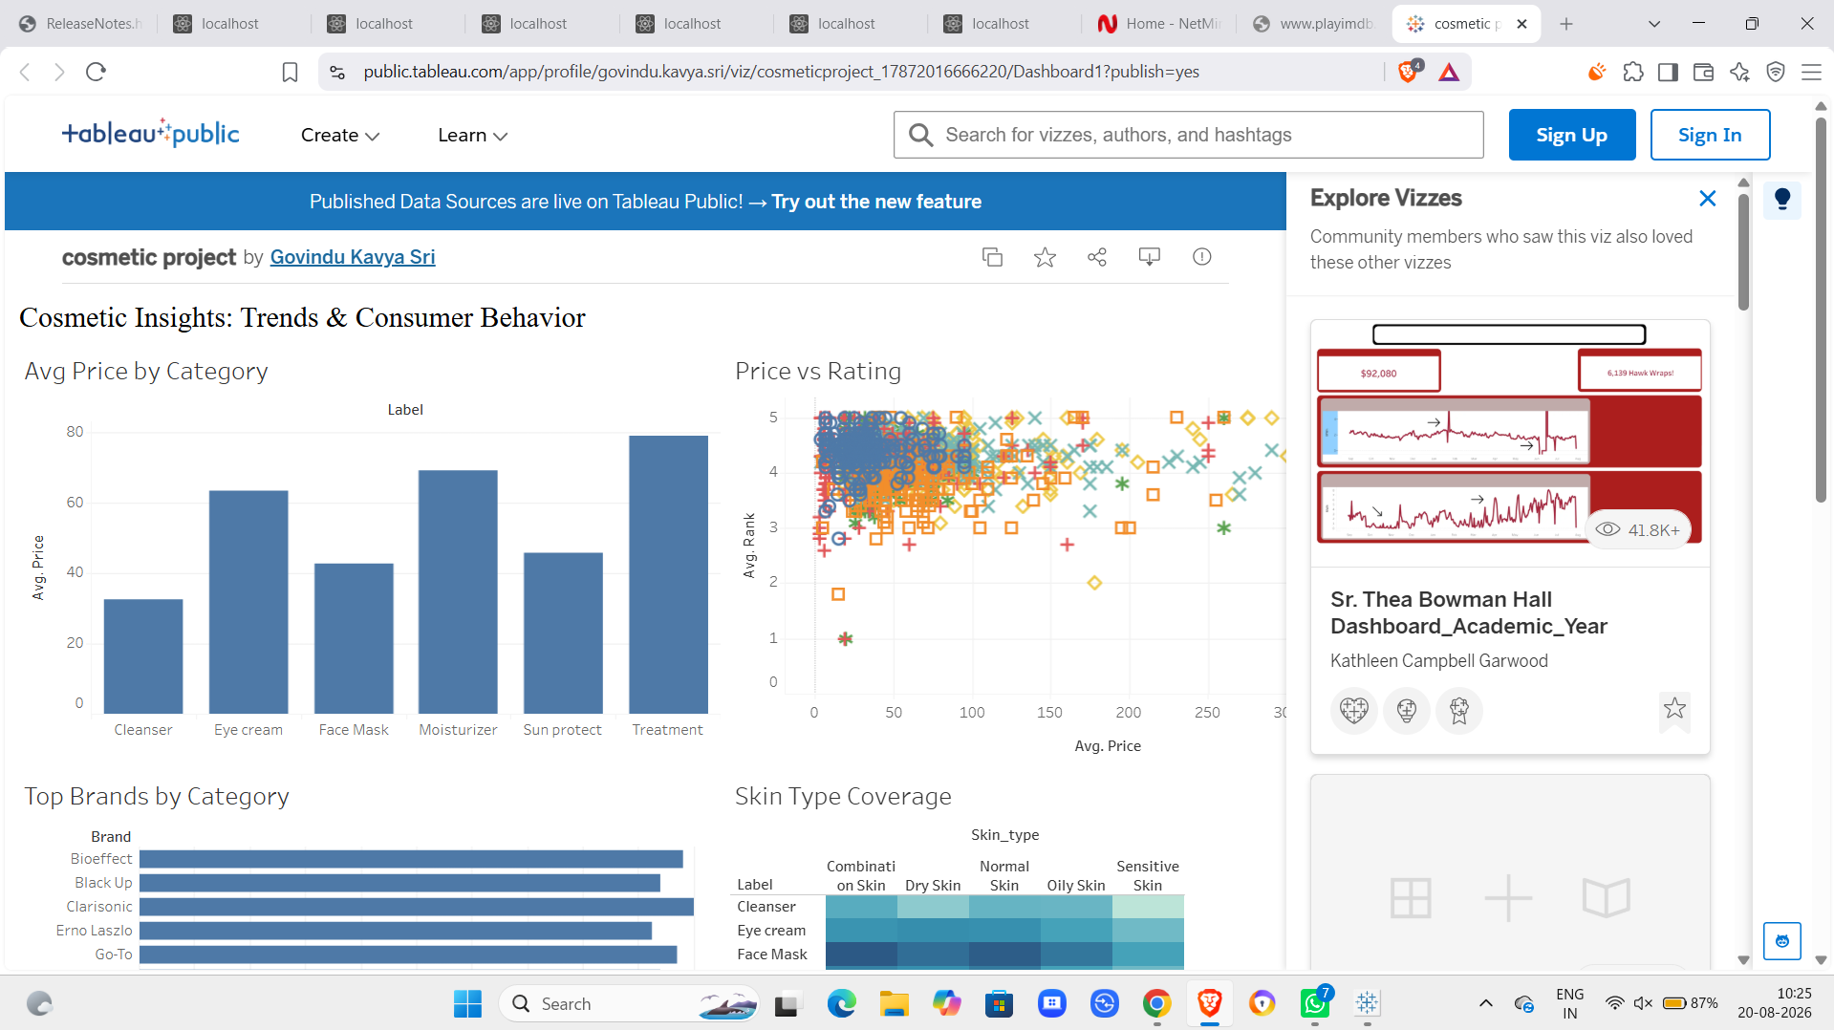
Dashboard 1 as published live on Tableau Public, viewable by anyone with the link, no login required

2. Narrative Structure (Story)
Rather than a separate multi-point Tableau Story, this project delivers its narrative through a single combined dashboard whose four charts are designed to be read in sequence — category pricing, then price-to-rating value, then top brands, then skin-type fit — with cross-chart filtering letting any persona (Priya, Meera, or Arjun) narrow the same view to their own question. Building out a dedicated multi-point Tableau Story as a guided presentation layer is noted as a Future Scope item.

